## **PROPLED - A BLOCKCHAIN BASED REAL ESTATE MARKET**

A PROJECT REPORT

***Submitted by***

|  |  |
| --- | --- |
| **JAIDEEP RP.** | **(412416205025)** |
| **VIJAY G.** | **(412416205092)** |
| **YOGESH MUDALIAR V.** | **(412416205100)** |

***in partial fulfilment for the award of the degree***

***of***

# **BACHELOR OF TECHNOLOGY**

***in***

**INFORMATION TECHNOLOGY**

**SRI SAIRAM INSTITUTE OF TECHNOLOGY, WEST TAMBARAM**

# **ANNA UNIVERSITY: CHENNAI 600 025**

2019- 2020

**BONAFIDE CERTIFICATE**

Certified that this project report **“PropLed: A Blockchain based Real Estate market**​**”** is the bonafide work of “**JAIDEEP RP (412416205025), VIJAY G (412416205092) and YOGESH MUDALIAR V (412416205100)”** who carried out the project work under my supervision.

|  |  |
| --- | --- |
| **SIGNATURE** | **SIGNATURE** |
|  |  |
| **Mrs. J. GHAYATHRI**  **M.E.** | **Dr. V. BRINDHA DEVI**  **M.E., Ph.D.** |
| **SUPERVISOR** | **HEAD OF THE DEPARTMENT** |
| Assistant Professor | Associate Professor |

Submitted for Anna University Project Viva Voce held on …..22-09-2020… at Sri Sai Ram Institute of Technology, Chennai -600044.

**SUPERVISOR EXAMINER PROJECT CO-ORDINATOR**

Mrs. J. Ghayathri Dr.D.Gokula Krishnan Dr. D. Murugaradha Devi

**ACKNOWLEDGEMENT**

A successful man is one who can lay a firm foundation with the bricks others have thrown at him. —*David Brinkley*

Such a successful personality is our beloved founder Chairman, **Thiru. MJF. Ln. LEO MUTHU.** At first, we express our sincere gratitude to our beloved chairman through prayers, who in the form of a guiding star has spread his wings of external support with immortal blessings.

We express our gratitude to our CEO **Mr. J. SAI PRAKASH LEO MUTHU** and our Trustee **Mrs. J. SHARMILA RAJA** for their constant encouragement for completing this project.

We express our sincere thanks to our beloved Principal, **Dr. K. PALANIKUMAR for** having given us spontaneous and wholehearted encouragement for completing this project.

We are indebted to our HEAD OF THE DEPARTMENT **Dr.V. BRINDA DEVI** for her support during the entire course of this project work.

We express our gratitude and sincere thanks to our project guide and Co-Ordinator **Mrs. J.M. NANDHINI** for her valuable suggestions and constant encouragement for the successful completion of this project.

We thank of all the teaching and Non-teaching staff members of the department of Information Technology and all others who contributed directly or indirectly for the successful completion of project.

**TABLE OF CONTENT**

|  |  |  |
| --- | --- | --- |
| CHAPTER NO | TITLE | PAGE NO |
|  | ACKNOWLEDGEMENT  ABSTRACT  LIST OF FIGURES    LIST OF ABBREVIATIONS | 3  7  8  9 |
| 1 | INTRODUCTION | 10 |
|  | 1.1 Overview of Blockchain | 10 |
|  | 1.1.1 Applications of Blockchain | 11 |
|  | 1.1.2 Blockchain in Supply Chain | 11 |
|  | 1.2Current Real Estate System | 12 |
|  | 1.3 Blockchain in Real Estate | 13 |
| 2 | LITERATURE SURVEY | 14 |
| 3 | SYSTEM ANALYSIS AND REQUIREMENT SPECIFICATION | 17 |
|  | 3.1 Existing System | 17 |
|  | 3.2 Proposed System | 18 |
|  | 3.3 Advantages | 18 |
|  | 3.4 REQUIREMENTS SPECIFICATION | 19 |
|  | 3.4.1 Economical feasibility | 19 |
|  | 3.4.2 Technical feasibility | 20 |
|  | 3.4.3 Social feasibility | 20 |
|  | 3.5 Hardware and Software Specification | 21 |
|  | 3.5.1 Hardware Requirements | 21 |
|  | 3.5.2 Software Requirements | 21 |
| 4 | SYSTEM DESIGN | 22 |
|  | 4.1 Architecture Diagram | 22 |
|  | 4.2 Sequence Diagram | 22 |
|  | 4.3 Activity Diagram | 24 |
|  | 4.4 Collaboration Diagram | 25 |
|  | 4.5 Deployment Diagram | 26 |
| 5 | PROJECT DESCRIPTION AND TECHNOLOGIES USED | 27 |
|  | 5.1 Blockchain | 27 |
|  | 5.2 Decentralized Applications | 27 |
|  | 5.3 The Ethereum Blockchain | 28 |
|  | 5.4 Solidity: The Contract-Oriented Language | 32 |
|  | 5.5 Ganache | 36 |
|  | 5.6 Node JS | 37 |
|  | 5.7 Metamask – Extension | 39 |
|  | 5.8 Module description | 39 |
| 6 | TESTING | 43 |
|  | 6.1 Unit Testing | 43 |
|  | 6.2 Integration Testing | 44 |
|  | 6.3 Acceptance Testing | 46 |
|  | APPENDIX I | 47 |
|  | APPENDIX II | 82 |
| 7 | CONCLUSION AND FUTURE ENHANCEMENT | 86 |
|  | References | 87 |

**ABSTRACT**

Global real estate (RE) investments account more than twice the size of the stock market. Yet the number of investors in RE are much lower, because of the liquidity and global access. Tenants, owners, and investors are barely satisﬁed in the current system. In this paper, the goal is to try out the employment of blockchain in RE market and represent the facilities it can give to the RE market. The research to date leads to the following conclusions: Blockchain technology can be applied to Real Estate transactions to save cost on fees, speed up the transactions, to avoid intermediaries and to provide additional security.

Blockchain technology and smart contracts can sort out the classical issues that RE is facing with, and they offer much more meaningful tools for a game theoretic stable-priced market.

**LIST OF FIGURES**

|  |  |  |
| --- | --- | --- |
| **FIGURE NO** | **CONTENTS** | **PAGE NO** |
| 4.1 | Architecture Diagram | 23 |
| 4.2 | Sequence Diagram | 24 |
| 4.3 | Activity Diagram | 25 |
| 4.4 | Collaboration Diagram | 26 |
| 4.5 | Deployment diagram | 27 |
| 5.1 | DApp Structure | 29 |
| 5.2 | Ethereum transactions | 31 |
| 5.3 | Ethereum virtual machine | 32 |
| 5.4 | Solidity compiler | 34 |
| 5.5 | Ganache | 37 |
| 5.6 | Ganache (Ethereum Accounts) | 38 |
| 5.7 | Http-server | 39 |
| 5.8 | Metamask extension | 40 |
| 7 | Appendix II | 83 |

**LIST OF ABBREVIATIONS**

|  |  |
| --- | --- |
| **RE** | Real Estate |
| **EVM** | Ethereum Virtual Machine |
| **DApp** | Decentralized Application |
| **HTML** | Hyper Text Markup Language |
| **npm** | Node Package Manager |
| **JSON** | JavaScript Object Notation |
| **RPC** | Remote Procedure Call |
| **UML** | Unified Modelling Language |
| **CSS** | Cascading Style Sheets |
| **ABI** | Application Binary Interface |
| **NAR** | National Association of Realtors |

**Chapter 1**

**Introduction**

**1.1 OVERVIEW OF BLOCKCHAIN**

The term "blockchain technology" typically refers to the transparent, trust less , publicly accessible ledger that allows us to securely transfer the ownership of units of value using public key encryption and proof of work methods. The technology uses decentralized consensus to maintain the network, which means it is not centrally controlled by a bank, corporation, or government. In fact, the larger the network grows and becomes increasingly decentralized, the more secure it becomes.

Blockchain is literally just a chain of blocks (“block” referring to digital information),stored in a public database (the “chain”).Blocks store information about transactions like the date, time, and dollar amount of your most recent purchase from Amazon. (NOTE: This Amazon example is for illustrative purchases; Amazon retail does not work on a blockchain principle as of this writing). Blocks store information about who is participating in transactions. The information is recorded using a unique “digital signature,” sort of like a username. Blocks store information that distinguishes them from other blocks. Each block stores a unique code called a “hash” that allows us to tell it apart from every other block. Hashes are cryptographic codes created by special algorithms.

**1.1.1 APPLICATIONS OF BLOCKCHAIN**

Blockchain technology can be integrated into multiple areas.The main areas are

* + - 1. Cryptocurrencies
      2. Smart contracts
      3. Financial services
      4. Video games
      5. Supply chain

**1.1.2 BLOCKCHAIN IN SUPPLY CHAIN**

Supply chain management includes the integrated planning as well as the execution of different processes. This involves material flow, information flow as well as financial capital flow. The management of the flow of goods, services, and information involving the storage and movement of raw materials, building products as well as full-fledged finished goods from one point to another is called supply chain management. A supply chain within the SCM is a network of individual entities, organizations, businesses, resources as well as technologies that combine together in the manufacturing of a product or service. Blockchain can be applied to many challenges of the Supply Chain industry such as complicated record keeping and tracking of products. As a less corruptible and better-automated alternative to centralised databases.

The real-time tracking of a product in a supply chain with the help of blockchain reduces the overall cost of moving items in a supply chain.The immutable nature of blockchain in the supply chain is well-designed to prevent tampering and establishing trust.

**1.2 CURRENT REAL ESTATE SYSTEM**

2018 is proving to be a turning point for the Indian real estate sector in many ways. With the current government’s renewed focus on affordable housing, game changing regulatory reforms, and infrastructure status to warehousing, business sentiment has been positive. The private equity investments in Indian real estate improved 15 per cent year-on-year in January March 2018 reaching USD3 billion1 billion and are estimated to grow to USD100 billion by 20262 with tier 1 and 2 cities benefiting the most in future. No so long ago, the Indian real estate sector was struggling with unsold inventory, reducing buyers’ confidence, delays in projects, and negative cash flows. However, a number of growths promoting regulatory developments and initiatives announced over the last two years, are paving the way for strong sector growth in the future.

Real estate sector in India is expected to reach US$ 1 trillion by 2030. By 2025, it will contribute 13 per cent of the country’s GDP. Real Estate stock in India is expected to reach 3.7 million square feet in 2019, with addition of 200 million square feet during the year. Emergence of nuclear families, rapid urbanisation and rising household income are likely to remain the key drivers for growth in all spheres of real estate, including residential, commercial and retail. Rapid urbanisation in the country is pushing the growth of real estate. More than 70 per cent of India’s GDP will be contributed by the urban areas by 2020. Indian real estate increased by 19.5 per cent CAGR from 2017 to 2028.

As Real Estate is one of the growing investment sectors in India, as well as in other countries. Every one wishes to invest in Real Estate but they are afraid of fraud, losing of money, fake credentials, etc. In order to overcome this we are introducing blockchain in real estate as it is one of the safest, immutable, faster technology present till now.

**1.3 BLOCKCHAIN IN REAL ESTATE**

RE investment is considered one of the safest options for investing. For that we have: it provides security to investors and is a hedge against inflation (money inflation). It is also a physical asset that is excellent for portfolio diversification, and can be non-volatile and essentially risk-free over a long period of time. RE investment is available to everyone as opposed to for experts only.

The real estate sector is one of the most profitable industries in the world. The real estate business is the process of selling and buying the assets. It is impossible to know when the first real estate transaction took place. So many new technologies have appeared to make the real estate business in advance throughout the year. On May 13, 1908 the National Association of Realtors (NAR) was founded as the National Association of Real Estate Exchanges in Chicago, that brings the brokers and agents together to facilitate the real estate business.[2] Nowadays the real estate business is described as inefficient due to its paper based and manual approach and there are several intermediaries are included that increases both transaction costs and the duration of real estate transactions. Further it also increases the workload of manual review and verification of financial and legal documents which can be modified. These centralized paper-based systems can be crashed by third parties. Blockchain is a distributed technology which provides authentication, security, integrity and make the process faster. The blockchain technology support digital cryptocurrency to make the payment process more secure. By the concept of Smart contracts, the work be done and be audited automatically without the presence of middleman. A Smart contract is simply a piece of code which is considered as a law and two parties in a transaction agreed on its content.

**CHAPTER 2**

**LITERATURE SURVEY**

**Project title: BLOCKCHAIN-BASED REAL ESTATE MARKET: ONE METHOD FOR APPLYING BLOCKCHAIN TECHNOLOGY IN COMMERCIAL REAL ESTATE MARKET**

**Author Name:** Sobhan Latifi

Yunpeng Zhang

Liang-Chieh Cheng

**Abstract:** Global real estate (RE) investments account more than twice the size of the stock market. Yet the number of investors in RE are much lower, because of the liquidity and global access. Tenants, owners, and investors are barely satisfied in the current system. In this paper, the goal is to try out the employment of blockchain in RE market and represent the facilities it can give to the RE market.The research to date leads to the following conclusions: Blockchain technology and smart contracts can sort out the classical issues that RE is facing with, and they offer much more meaningful tools for a game theoretic stable-priced market.

**Project Title: THE IMPACT OF BLOCKCHAIN TECHNOLOGY ON THE REAL ESTATE SECTOR USING SMART CONTRACTS**

**Author Name:** Emadul Karim

Muhammad Mansab Uzair

**Abstract :** The block chain technology has been in the topic of much discussion due to its successful application in the crypto currency known as “Bitcoin" which has investment experts, economists, billion dollar financial institutes, big banks as well as governments taking sides on whether it should be legitimized and used as a currency or make it illegal to be used as a means of exchange. However, experts from different field like supply chain management and even from the medical field are more interested in how the block chain technology’s decentralized record keeping and numerous other benefits can be of use to them in their fields of work. This study concentrates on the block chain being used for real estate record keeping, since most geography’s have different procedures for record keeping, this study focuses on defense Housing Authority in Karachi to check what the impact of applying the block chain technology to this area in Karachi would have on investors, real estate agents, residents and the government.

**Project Title: SECURED REAL ESTATE TRANSACTIONS USING BLOCKCHAIN TECHNOLOGY**

**Author Name:** Sabarish Krishna D

SoumiAakash V

Sivaprakash M

Madhumathi C.S

**Abstract:** The Real Estate is facing a lot of problems including the trust issues, the path of how data shared and lot of automatic process. There are many organization agents, e-commerce websites and various other channels through which people can search a property for buying, leasing or putting their own property up for sale. The real estate by name itself has a lack of trust and transparency in data and record management. The public land title records are maintained in a local space, and the lenders need to contact the relevant local entities for each title assurance process, hence the maintenance cost of asset data from a transactional perspective is high and its required to maintain a title and search for public records which contribute to delay and higher costs . A solution for monitoring and transferring properties in a secure way can drastically reduce title search, examination time and costs. Blockchain is a decentralized data management and transaction solution, has the potential to address many of the challenges faced by this industry.

**CHAPTER 3**

**SYSTEM ANALYSIS AND REQUIREMENT SECIFICATION**

**3.1 EXISTING SYSTEM**

It takes an average of 114 days from the time the property is listed to the official transfer day occurs for small assets. A real estate transaction usually occurs in five steps listing, searching, evaluating, negotiation and execution, which in turns include approximately 33 steps. In current system, the repeated process of validating information such as title deed, encumbrance certificate, katha, building plan, NOC, tax receipts, check for bank approval. The validation of the documents needs to be done through manual processes and it takes more time and cost. Today, commercial brokers and other middlemen are struggling hard with old-fashioned technology, data sharing mechanisms, inefficient cash flow management, real-time performance data, and so forth. These drawbacks cause collision and other side effects for buyer and seller. The digital real estate market is a centralized platform with central authority, who have a right to access the data within the digital platform. Moreover, there are many barriers in current system that could be international bank accounts, citizenship, credit score, financing, cash requirements, accreditation. If you are planning to buy a land in foreign country you will have to make at least one international trip to visit the land. You will have to spend lot of time, money and go through several middlemen to invest in the land of your choice.

**3.2 PROPOSED SYSTEM**

We propose a design methodology for the smart contract which enables development of different use cases using Blockchain technology. A detailed state finite functions and processes are described for a specific use case providing noteworthy contributions to real estate domain. In this frame, the blockchain becomes the enabler for the development of paperless layer for all city transactions, in a secure fashion for the optimum management of the smart city’s assets. With this idea, the smart contract provides a secure, distributed and shared decentralized ledger of all assets and transactions between landlord and tenants. And provide security by binding the latitude and longitude value of land along with the owner’s unique identification in the smart contract and this helps to reduce the illegal activities.

**3.3 ADVANTAGES**

* **Trackability**

When an information is updated in the ledger. The data becomes traceable throughout the network.

* **Transparency**

Blockchain provides provenance, traceability and transparency of transactions.

* **Real Time sharing**

When information is updated, it’s updated for everyone in the network at the same time.

* **Authenticity**

Since Blockchain supports provenance, hence the proliferation of counterfeit drugs can be minimized.

* **Decentralized**

Distributed digital ledger that is used to record transactions across many computers so that any involved record cannot be altered retroactively, without the alteration of all subsequent blocks.

* **No need for middleman**

No brokers, assistants are required as it can be done single handily.

* **Immutability**

Thedata which is stored once can't be modified after being instantiated. If we want to change the value of that thing, we must recreate it with the new value instead.

* **Fast Processing**

Quicker as compared to manual process used in society.

**3.4 REQUIREMENT SPECIFICATIONS**

The feasibility of the project is analysed in this phase and business proposal is put forth with a very general plan for the project and some cost estimates. During system analysis the feasibility study of the proposed system is to be carried out.This is to ensure that the proposed system is not a burden to the company. For feasibility analysis, some understanding of the major requirements for the system is essential.

Three key considerations involved in the feasibility analysis are

♦ Economical feasibility

♦ Technical feasibility

♦ Social feasibility

**3.4.1 ECONOMICAL FEASIBILITY**

This study is carried out to check the economic impact that the system will have on the organization. The amount of funds that the company can pour into the research and development of the system is limited. The expenditures must be justified. Thus the developed system as well within the budget and this was achieved because most of the technologies used are freely available. Only the customized products had to be purchased.

**3.4.2 TECHNICAL FEASIBILITY**

This study is carried out to check the technical feasibility, that is, the technical requirements of the system. Any system developed must not have a high demand on the available technical resources. This will lead to high demands on the available technical resources. This will lead to high demands being placed on the client. The developed system must have a modest requirement, as only minimal or null changes are required for implementing this system.

**3.4.3 SOCIAL FEASIBILITY**

The aspect of study is to check the level of acceptance of the system by the user. This includes the process of training the user to use the system efficiently. The user must not feel threatened by the system, instead must accept it as a necessity. The level of acceptance by the users solely depends on the methods that are employed to educate the user about the system and to make him familiar with it. His level of confidence must be raised so that he is also able to make some constructive criticism, which is welcomed, as he is the final user of the system.

**3.5 HARDWARE AND SOFTWARE SPECIFICATION**

**3.5.1 HARDWARE REQUIREMENTS**

The hardware requirements may serve as the basis for a contract for the implementation of the system and should therefore be a complete and consistent specification of the whole system. They are used by software engineers as the starting point for the system design. It shows what the systems do and not how it should be implemented.

System: Pentium IV 2.4 GHz and above.​

Hard Disk: 40 GB.

Ram: 512 Mb.

Monitor: 15 VGA Colour.

Mouse, Keyboard

**3.5.2 SOFTWARE REQUIREMENTS**

The software requirements are the specification of the system. It should include both a definition and a specification of requirements. It is a set of what the system should do rather than how it should do it. The software requirements provide a basis for creating the software requirements specification.

FRONT-END: HTML, CSS

INTERFACING: Web3, jQuery

SMART CONTRACT: Solidity

PLATFORM: Ethereum

IDE: Remix, VS Code

ENVIRONMENT: Node JS (http-server)

**CHAPTER 4**

**SYSTEM DESIGN**

**4.1 ARCHITECTURE DIAGRAM:**

System architecture defines the way the system works along with modules and it also describes the way each module works and hence describes the overall working. The following diagram describes the system architecture.

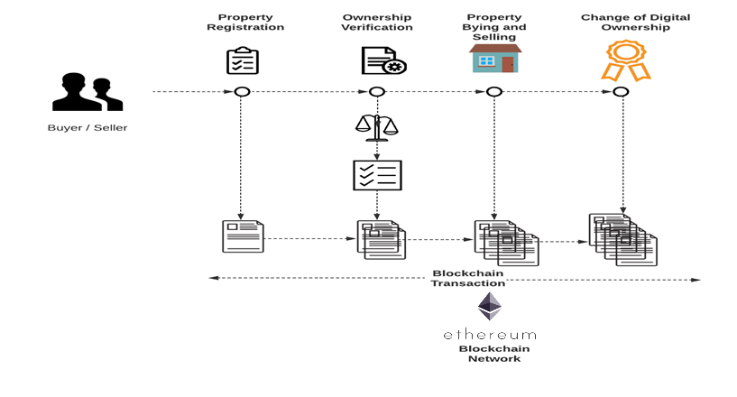

**Fig 4.1 Architecture diagram**

**4.2 SEQUENCE DIAGRAM:**

A sequence diagram shows object interactions arranged in time sequence. It depicts the objects and classes involved in the scenario and the sequence of messages exchanged between the objects needed to carry out the functionality of the scenario. Sequence diagrams are typically associated with use case realizations in the [Logical View](https://en.wikipedia.org/wiki/4%2B1_architectural_view_model) of the system under development. Sequence diagrams are sometimes called event diagrams or event scenarios.

A sequence diagram shows, as parallel vertical lines (*lifelines*), different processes or objects that live simultaneously, and, as horizontal arrows, the messages exchanged between them, in the order in which they occur. This allows the specification of simple runtime scenarios in a graphical manner.

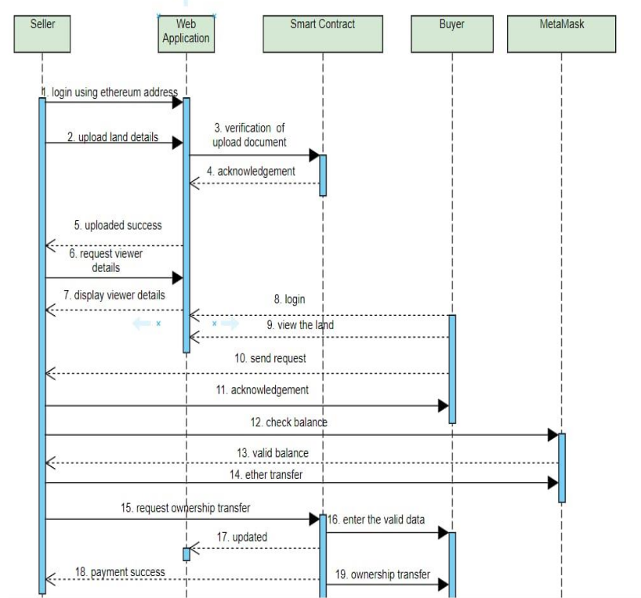

**Fig 4.2 Sequence Diagram**

**4.3 ACTIVITY DIAGRAM:**

Activity diagrams are graphical representations of [workflows](https://en.wikipedia.org/wiki/Workflow) of stepwise activities and actions with support for choice, iteration and concurrency. In the [Unified Modelling Language](https://en.wikipedia.org/wiki/Unified_Modeling_Language), activity diagrams are intended to model both computational and organizational processes (i.e., workflows), as well as the data flows intersecting with the related activities. Although activity diagrams primarily show the overall flow of control, they can also include elements showing the flow of data between activities through one or more data stores.

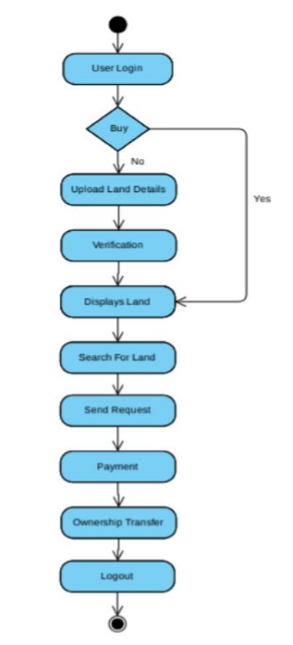

**Fig 4.3 Activity Diagram**

**4.4 COLLABORATION DIAGRAM**

A collaboration diagram, also known as a communication diagram, is an illustration of the relationships and interactions among software [objects](https://searchapparchitecture.techtarget.com/definition/object) in the Unified Modelling Language ([UML](https://searchsoftwarequality.techtarget.com/definition/Unified-Modeling-Language)). These diagrams can be used to portray the dynamic behaviour of a particular [use case](https://searchsoftwarequality.techtarget.com/definition/use-case) and define the role of each object.

Collaboration diagrams are created by first identifying the structural elements required to carry out the functionality of an interaction. A model is then built using the relationships between those elements. Several vendors offer software for creating and editing collaboration diagrams.

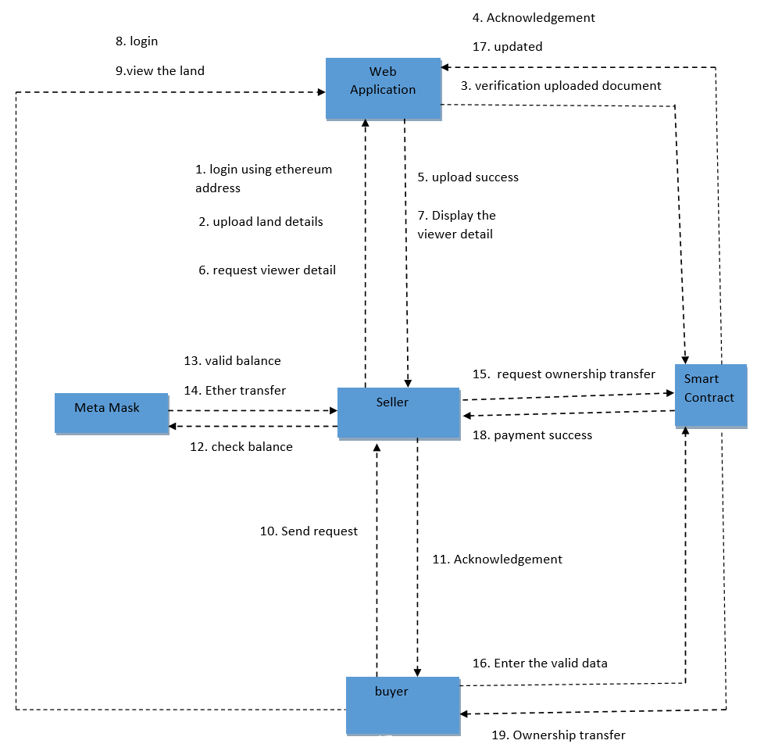

**Fig 4.4 Collaboration diagram**

**4.5 DEPLOYMENT DIAGRAM**

Component diagrams are used to describe the components and deployment diagrams show how they are deployed in hardware. UML is mainly designed to focus on the software artifacts of a system. However, these two diagrams are special diagrams used to focus on software and hardware components. The software components speak about the components required by the system related to software and hardware components speaks about the hardware required by the system.

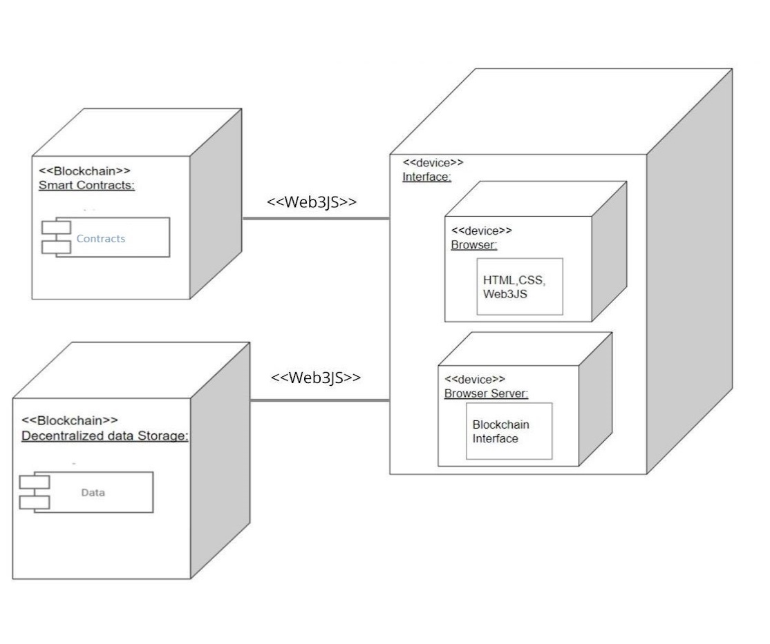

**Fig 4.5 Deployment diagram**

**CHAPTER 5**

**PROJECT DESCRIPTION AND TECHNOLOGIES USED**

**5.1 BLOCKCHAIN**

Blockchain is a digital structure of data that represents a record of transaction and it is a shared database technology which supports the development of security accused applications which uses cryptocurrencies. Blockchain is a time-stamped series of unchangeable records of data that is managed by a group of computers not owned by any single party. Each of these blocks of data is highly secured and connected to each other using cryptographic algorithms, which is nothing but a chain. Blockchain has no centre authority and it allows creation of public records that can be shared and its information in it is open for anyone and everyone to see. Anything that is built on blockchain is transparent by nature. Blockchain supports digital crypto currency so our system is safe from attackers or thieves. A digital ledger stores transactions or related metadata immutability.

**5.2 DECENTRALIZED APPLICATIONS (DAPPS)**

A Decentralized Application (DApp) is an application that uses smart contracts providing a friendly user interface to smart contracts. A typical example of DApp is a crypto currency application that runs on a blockchain network. A Decentralized application structure is composed by a front-end interface (Web Browser, HTML, CSS) and a back-end interface (Web3 JavaScript). As described in below figure the DApp application interacts with the Ethereum node (EVM) using JSON RPC. JSON RPC is a stateless and lightweight remote procedure call (RPC) protocol that is used by Ethereum clients to interact with an Ethereum node.

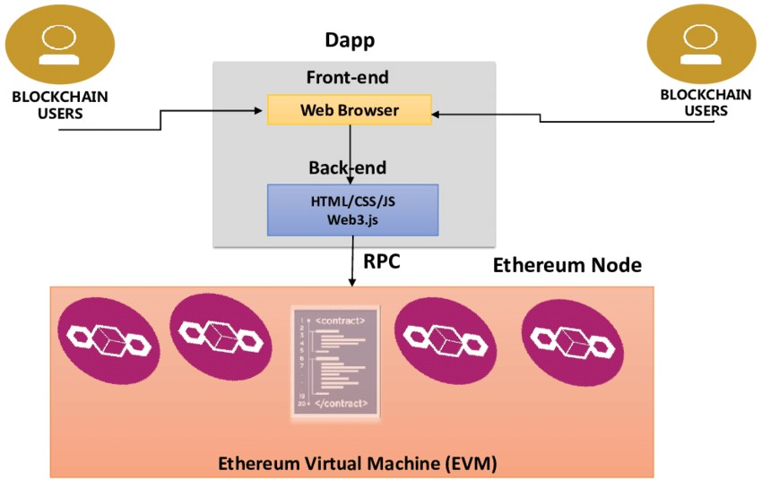

**Fig 5.1 DApp Structure**

**5.3 THE ETHEREUM BLOCKCHAIN**

Ethereum is an open source, public, blockchain based distributed computing platform and operating system featuring smart contract functionality. Ether is the crypto currency generated by ethereum platform. Ethereum provides a decentralized virtual machine, the Ethereum Virtual Machine (EVM) which can execute scripts using an international network of public notes. Smart Contract in Ethereum is just a phrase used to describe a computer code that can facilitate the exchange of money, content, property, shares, or anything of value. The Ethereum platform provides more benefits from all of its properties such as immutability, corruption &amp; tamper proof, secure, zero downtime. ETHER is a fundamental token for operation of Ethereum, which thereby provides a public distributed ledger for transactions. The Ether acts as the “fuel” that powers the Ethereum network. Ether is the crypto-fuel allowing smart contracts to run. The Ethereum Virtual Machine (EVM) is the run time environment for smart contracts in Ethereum. It is the fundamental consensus mechanism for Ethereum. Ethereum smart contracts can be written in solidity, serpent, LLL and Mutan.

**Ether:**

Ether is a fundamental token for operation of Ethereum, which thereby provides a public distributed ledger for transactions. It is used to pay for gas, a unit of computation used in transactions and other state transitions.

It is listed under the ticker symbol ETH and traded on cryptocurrency exchanges, and the Greek uppercase Xi character (Ξ) is generally used for its currency symbol. It is also used to pay for transaction fees and computational services on the Ethereum network.

**Characteristics:**

As with other cryptocurrencies, the validity of each ether is provided by a blockchain, which is a continuously growing list of records, called *blocks*​ ​, which are linked and secured using cryptography. By design, the blockchain is inherently resistant to modification of the data. It is an open, distributed ledger that records transactions between two parties efficiently and in a verifiable and permanent way. Unlike Bitcoin, Ethereum operates using accounts and balances in a manner called state transitions. This does not rely upon unspent transaction outputs (UTXOs). The state denotes the current balances of all accounts and extra data. The state is not stored on the blockchain, it is stored in a separate Merkle Patricia tree. A cryptocurrency wallet stores the public and private "keys" or "addresses" which can be used to receive or spend ether. These can be generated through BIP 39 style mnemonics for a BIP

32 "HD Wallet". In Ethereum, this is unnecessary as it does not operate in a UTXO scheme. With the private key, it is possible to write in the blockchain, effectively making an ether transaction.

To send ether to an account, you need the Keccak-256 hash of the public key of that account. Ether accounts are pseudonymous in that they are not linked to individual persons, but rather to one or more specific addresses.

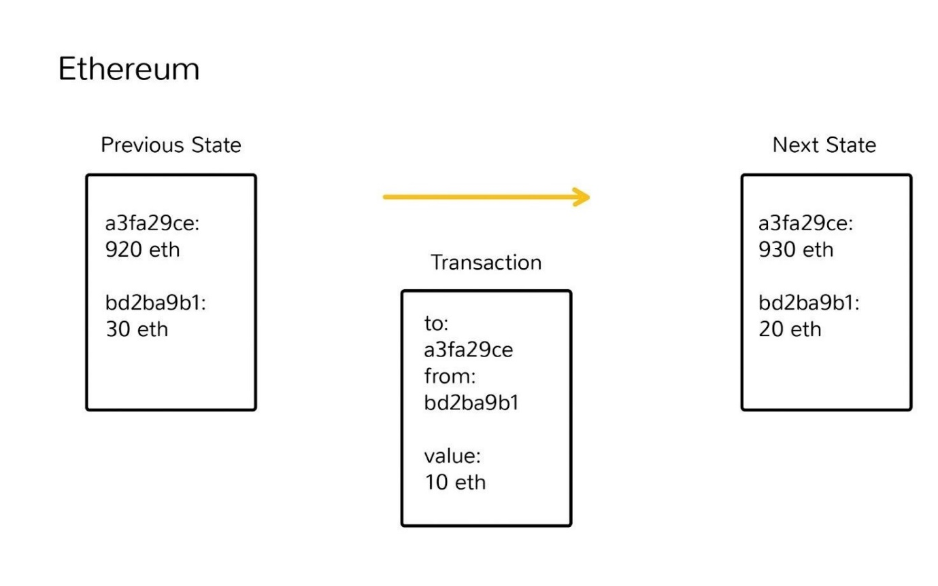

**Fig 5.2 Ethereum transactions**

**Overview of Ethereum smart contract?**

Smart Contract is used to describe a computer code that can facilitate the exchange of money, content, property, shares, or anything of value. When running on the blockchain a smart contract becomes like a self-operating computer program that automatically executes when specific conditions are met. Because smart contracts run on the blockchain, they run exactly as programmed without any possibility of censorship, downtime, fraud or third-party interference.

While all blockchains have the ability to process code, most are severely limited. Ethereum is different. Rather than giving a set of limited operations, Ethereum allows developers to create whatever operations they want. This means developers can build thousands of different applications that go way beyond anything we have seen before.

**The Ethereum Virtual Machine (EVM):**

With ethereum, every time a program is used, a network of thousands of computers processes it.

Contracts written in smart contract-specific programming languages are compiled into ‘bytecode’, which a feature called the ‘ethereum virtual machine’ (EVM) can read and execute.

All the nodes execute this contract using their EVMs.

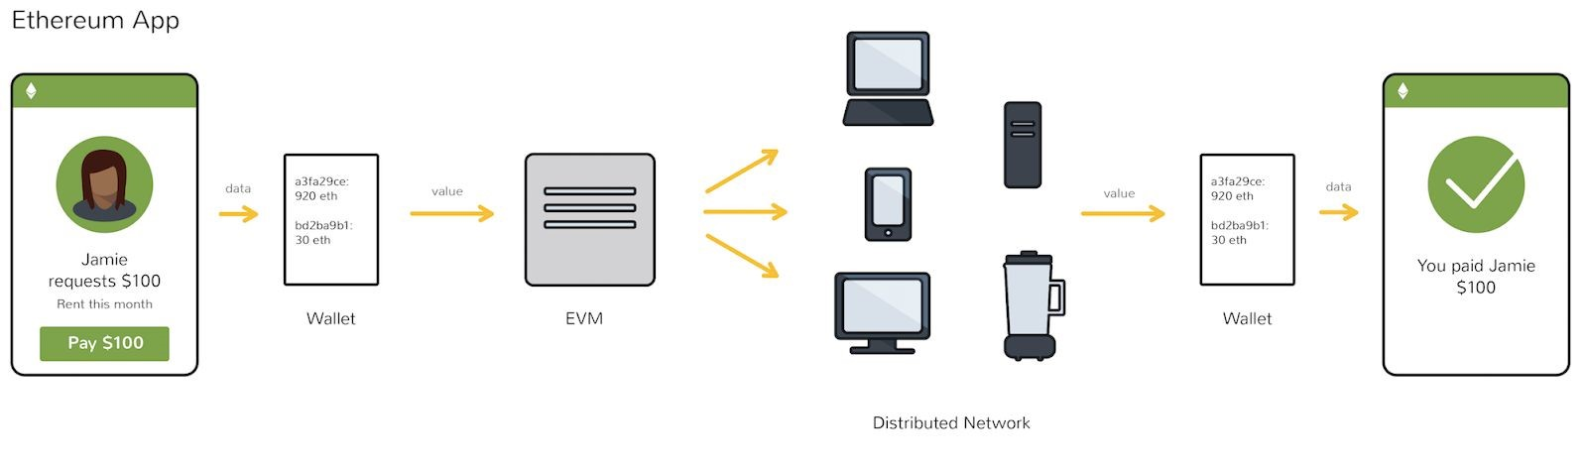

**Fig 5.3 Ethereum virtual machine**

Remember that every node in the network holds a copy of the transaction and smart contract history of the network, in addition to keeping track of the current ‘state’. Every time a user performs some action, all of the nodes on the network need to come to agreement that this change took place.

The goal here is for the network of miners and nodes to take responsibility for transferring the shift from state to state, rather than some authority such as PayPal or a bank. Bitcoin miners validate the shift of ownership of bitcoins from one person to another. The EVM executes a contract with whatever rules the developer initially programmed.

Actual computation on the EVM is achieved through a stack-based bytecode language (the ones and zeroes that a machine can read), but developers can write smart contracts in high-level languages such as Solidity and Serpent that are easier for humans to read and write.

**5.4 SOLIDITY: THE CONTRACT-ORIENTED LANGUAGE:**

Solidity is the main programming language for writing smart contracts for the Ethereum blockchain. It is a contract-oriented language, which means that smart contracts are responsible for storing all of the programming logic that transacts with the blockchain. It's a high-level programming language that looks a lot like JavaScript, Python, and C++. It's designed to run on the Ethereum Virtual Machine (EVM), which is hosted on Ethereum Nodes that are connected to the blockchain. It is statically typed, and supports inheritance, libraries, and more! In short, it has all the capability that you need in order to build industrial strength blockchain applications.

We're going to use Remix to write all of the code in this tutorial. Remix is a browser-based IDE that allows you to write, compile, deploy smart contracts! It has a lot of nice features like persistent file storage!

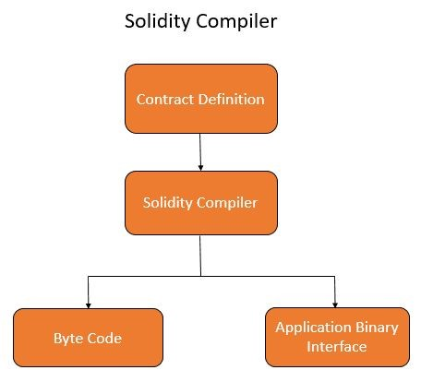

### **Fig5.4 Solidity compiler**

Contracts in solidity are similar to classes in object oriented language.

A contract can be created using “new” keyword

contract L {

function add(uint _p, uint _q) returns (uint) {

return _p + _q;

} }

contract M {

address p;

function f(uint _p) {

p = new L();

}

}

**ABI:**

A data encoding scheme called “Application Binary Interface” (ABI) is used in for working with smart contracts

**Pragma:**

Pragmas in solidity are used to specify certain conditions under which the source files can or cannot run

Example:

pragma solidity ^0.2.32

This code compiles with a compiler function >=0.2.32

A pseudocode example for pragma syntax

‘pragma’ Identifier ([^;]+) ‘;’

**Data Types:**

Data type is a particular kind of data defined by the values it can take

**Boolean**

Boolean syntax: bool: true or false

**Integer**

Unsigned Integer:

Eg: uint8 | uint16 | uint32 | unit64 | uint128 | uint256 (uint) Signed integer: int8 | int16 | int32 | nit64 | int128 | int256 (uint)

**Address:**

Holds an Ethereum address (20 byte value).

**Array:**

Array can be dynamic or fixed size array

uint[] dynamicSizeArray; uint[9] fixedSizeArray;

**Struct:**

New types can be declared using

**Mapping:**

Mapping can be seen as hash tables, declared as mapping(_KeyType => _ValueType)

**Function:**

Syntax of a function:

function (<parameter types>) {internal|external|public|private} [pure|constant|view|payable] [returns (<return types>] Pure functions: function f(uint a) pure returns (uint) { return a *24}

**5.5 GANACHE:**

The dependency is a personal blockchain, which is a local development blockchain that can be used to mimic the behavior of a public blockchain. I recommend using Ganache as your personal blockchain for Ethereum development. It will allow you to deploy smart contracts, develop applications, and run tests. It is available on Windows, Mac, and Linux as as a desktop application and a command line tool!

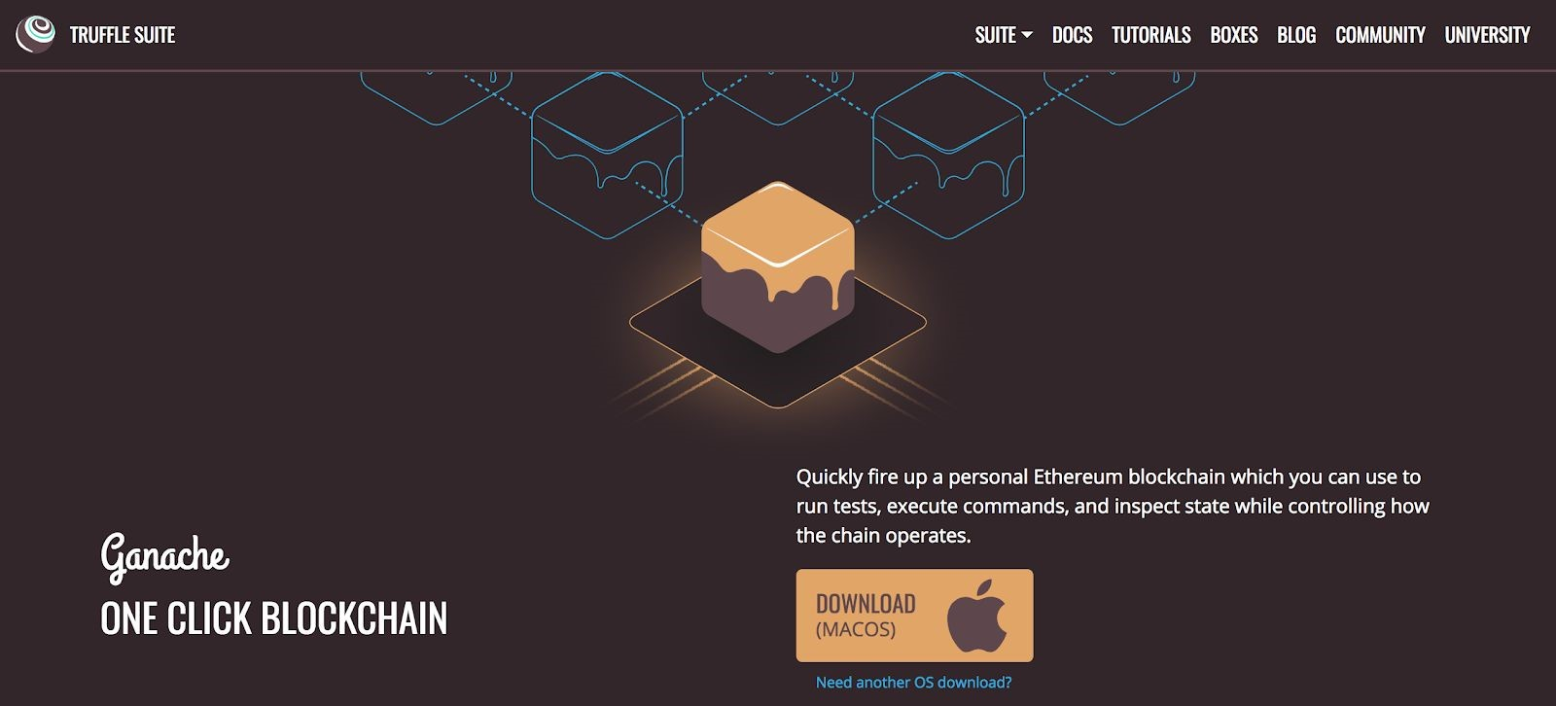

**Fig:5.5 Ganache**

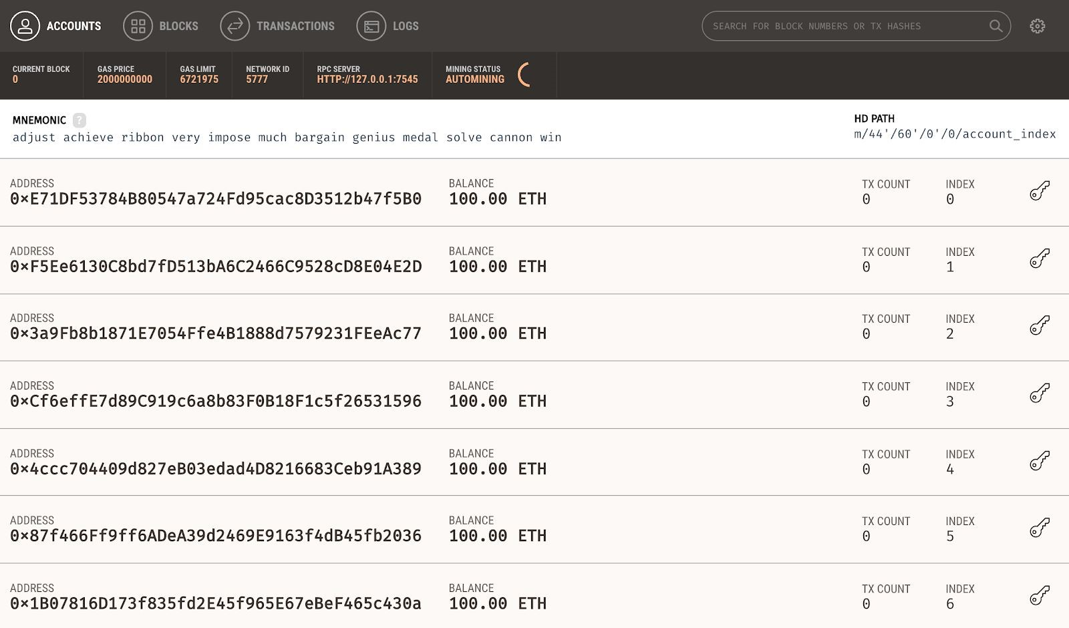

**Fig 5.6 Ganache(Accounts)**

**5.6 NODE JS:**

Node.js is an open-source, cross-platform, JavaScript runtime environment that executes JavaScript code outside of a web browser. Node.js lets developers use JavaScript to write command line tools and for server-side scripting—running scripts server-side to produce dynamic web page content before the page is sent to the user's web browser. Consequently, Node.js represents a "JavaScript everywhere" paradigm, unifying web-application development around a single programming language, rather than different languages for server- and client-side scripts.

The first dependency you'll need is Node Package Manager, or NPM, which comes with Node.js.

Download node js from [https://nodejs.org/en](https://nodejs.org/en/)​ [/](https://nodejs.org/en/)

To check the current version of node use this command: **node -v**​

**http-server setup in node:**

http-server is a simple, zero-configuration command-line http server. It is powerful enough​ for production usage, but it's simple and hackable enough to be used for testing, local development, and learning. **Installation via npm:**​

**npm install http-server -g**

This will install http-server globally so that it may be run from the command line.

**Usage:**

http-server [path] [options]

Now you can visit [http://localhost:808](http://localhost:8080/)​ [0](http://localhost:8080/) ​ to view your server

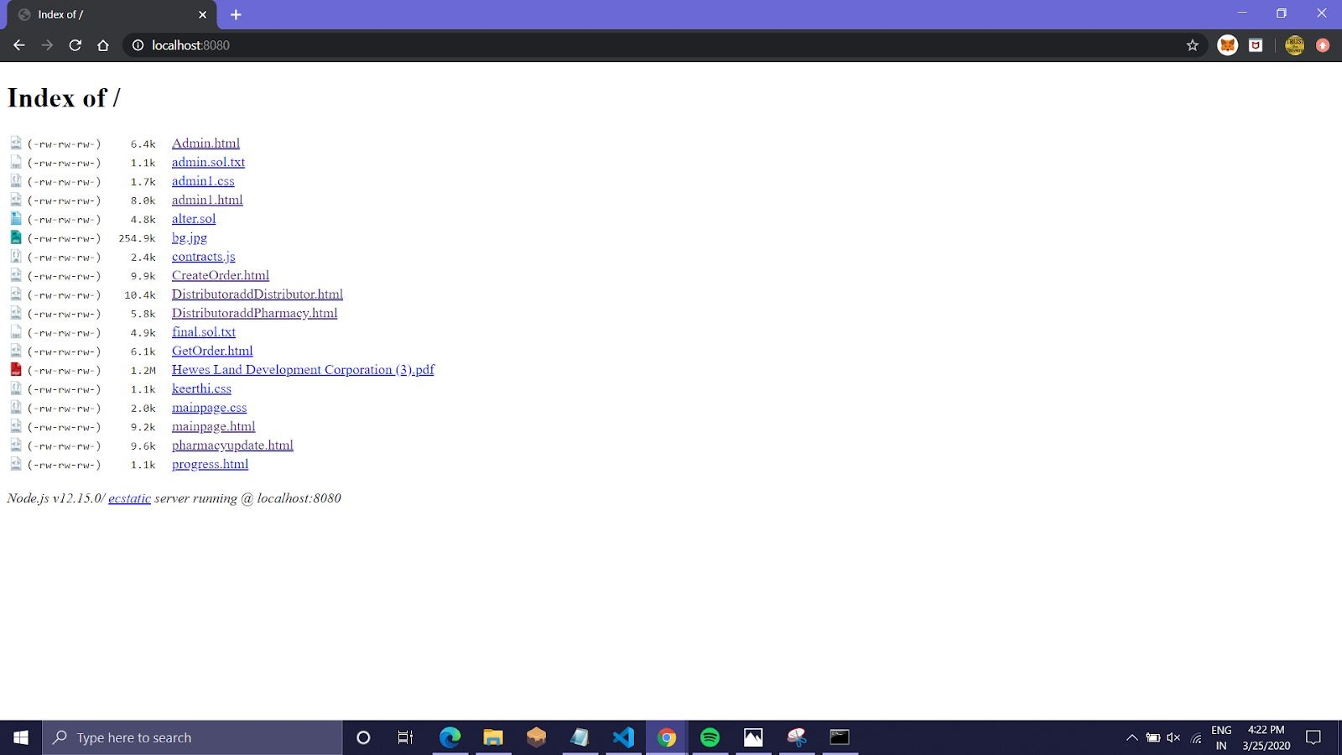

**Fig 5.7. Http-server**

**5.7 METAMASK – EXTENSION**

Metamask is a crypto currency wallet which can be used on the Chrome, Firefox and Brave browsers. It’s also a browser extension. This means that it works like a bridge between normal browsers and the Ethereum blockchain.

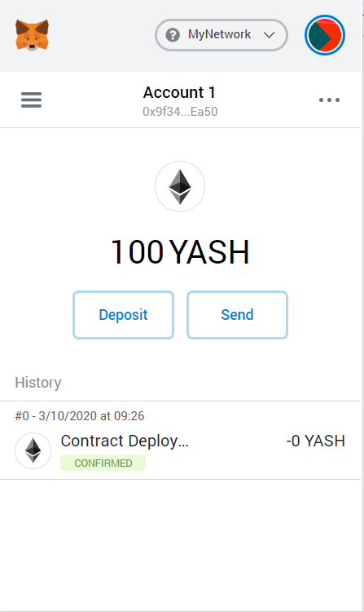 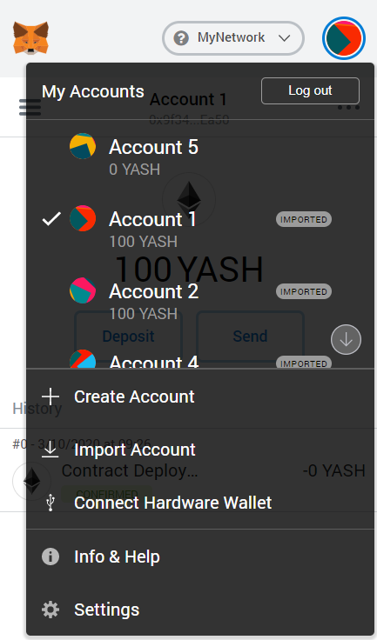

**Fig 5.8 Metamask Extension**

**5.8 MODULE DESCRIPTION**

There are totally five different Modules in this project. They are:

* Adding a new land to the system.
* Seller’s\Current owner’s module.
* Buyer’s module.
* Tracking the land’s owner module.
* Transferring ownership/Registration of land.

**I. ADDING A NEW LAND TO THE SYSTEM**

This module is used to digitalise the documents in order to insert land into supply chain. This module can be operated by governmental or non-governmental organisations. As this is the first time the block (i.e. the land with unique id) is created.

 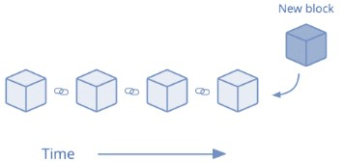

**Fig 5.9 Digitalising land records**

**II. SELLER’S\CURRENT OWNER’S MODULE**

This module is for the Land owner, who wishes to sell their land to someone. In order to sell land, one needs to give the details of land to the

system which is similar to publish-subscribe module. This module takes the seller details and sends it to the buyer’s interested in purchasing the land in seller’s area.



**Fig 5.10 Property for sale**

**III. Buyer’s module**

This module helps the buyer to provide contact details which is forwarded to the seller so that the seller can contact him/her in order to communicate regarding land details and negotiations which can be made before purchasing/selling of land or property. This helps to create a bond between buyer and seller.



**Fig 5.11 Sharing buyer’s contact to buyer**

**IV. TRACKING THE LAND’S OWNER MODULE**

In this module a particular land’s owner can be tracked by using lands unique identity, this is also helpful for inspections and to reduce the fraud. This also helps to know the information about the different owners who have purchased the since the land block is created in the system.



**Fig 5.12 Tracking Land owner**

**V. TRANSFERRING OWNERSHIP/REGISTRATION OF LAND**

In this module the seller can get access to the blockchain and with the help Ethereum account via Metamask the current owner gets access over his/her land and has a right transfer ownership to the buyer. As the owner gets right to change ownership once changed then can not be accessed by old owner (i.e. only the current owner gets access over the property).

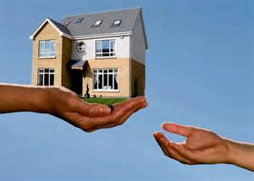

**Fig 5.13 Transferring ownership of land**

**CHAPTER 6**

**TESTING**

The purpose of testing is to discover errors. Testing is the process of trying to discover every conceivable fault or weakness in a work product. It provides a way to check the functionality of components, sub assemblies, assemblies and/or a finished product It is the process of exercising software with the intent of ensuring that the Software system meets its requirements and user expectations and does not fail in an unacceptable manner. There are various types of test. Each test type addresses a specific testing requirement.

**TYPES OF TESTS**

**6.1 UNIT TESTING:**

Unit testing is usually conducted as part of a combined code and unit

test phase of the software lifecycle, although it is not uncommon for coding and unit testing to be conducted as two distinct phases.

**6.1.1 TEST STRATEGY AND APPROACH**

Each one of the five modules were tested separately, no. of times with different input values in order to check the validation and working of the system and in order to check the connectivity of front end (HTML) and back end (Ethereum blockchain).

**6.1.2 TEST OBJECTIVES**

* All field entries must work properly.
* Pages must be activated from the identified link.
* The entry screen, messages and responses must not be delayed.

**6.1.3 FEATURES TO BE TESTED**

* Verify that the entries are of the correct format

* No duplicate entries should be allowed

* All links should take the user to the correct page.

**6.2 INTEGRATION TESTING:**

Software integration testing is the incremental integration testing of

two or more integrated software components on a single platform to produce failures caused by interface defects. The task of the integration test is to check that components or software applications, e.g. components in a software system or – one step up – software applications at the company level – interact without error.

**Test Results:** All the test cases mentioned above passed successfully. No defects​ encountered.

**6.3 ACCEPTANCE TESTING:**

User Acceptance Testing is a critical phase of any project and

requires significant participation by the end user. It also ensures that the system meets the functional requirements.

**Test Results:** All the test cases mentioned above passed successfully. No defects​ encountered.

**APPENNDIX I**

**CODING**

**A1 SOLIDITY CODE:**

pragma solidity ^0.5.11;

contract RealEstate{

struct Land{

string Name; //Land owner name

address OwnerAddr; //Ethereum address

string Uid; // Aadhar number

string Latitude;

string Longitude;

}

address BuyerAddr;

string public BuyerName;

string public BuyerUid;

address public owner;

uint public id;

constructor() public

{

owner = msg.sender;

id=0;

}

modifier isOwner

{

require(msg.sender == owner);

}

mapping(uint256 => Land)public LandInfo;

Land[] public lands;

//For Adding new Land Details

function AddLand(address _ownerAddr,string memory _Name,string memory _Uid,string memory _Latitude,string memory _Longitude) public isOwner

{

LandInfo[++id].OwnerAddr=_ownerAddr;

LandInfo[id].Name = _Name;

LandInfo[id].Uid = _Uid;

LandInfo[id].Latitude =_Latitude;

LandInfo[id].Longitude = _Longitude;

}

//get id

function getid() public returns(uint256){

return id;

}

//Show Land Details

function showLand(uint _landID) view public returns (string memory,address,string memory,string memory,string memory) {

return ( LandInfo[_landID].Name,

LandInfo[_landID].OwnerAddr,

LandInfo[_landID].Uid,

LandInfo[_landID].Latitude,

LandInfo[_landID].Longitude

);

}

//Get the Buyer Details

function GetBuyerInfo(address _BuyerAddr,string memory _BuyerName,string memory _BuyerUid) public {

BuyerAddr=_BuyerAddr;

BuyerName = _BuyerName;

BuyerUid = _BuyerUid;

}

//Transfer the ownership

function TransferOwnerShip(uint _landID,address _BuyerAddr,string memory _BuyerName,string memory _BuyerUid) public{

LandInfo[_landID].OwnerAddr=_BuyerAddr;

LandInfo[_landID].Name = _BuyerName;

LandInfo[_landID].Uid =_BuyerUid;

}

}

**A2 ABI:**

{

"constant": false,

"inputs": [

{

"internalType": "address",

"name": "_ownerAddr",

"type": "address"

},

{

"internalType": "string",

"name": "_Name",

"type": "string"

},

{

"internalType": "string",

"name": "_Uid",

"type": "string"

},

{

"internalType": "string",

"name": "_Latitude",

"type": "string"

},

{

"internalType": "string",

"name": "_Longitude",

"type": "string"

}

],

"name": "AddLand",

"outputs": [],

"payable": false,

"stateMutability": "nonpayable",

"type": "function"

},

{

"constant": false,

"inputs": [

{

"internalType": "address",

"name": "_BuyerAddr",

"type": "address"

},

{

"internalType": "string",

"name": "_BuyerName",

"type": "string"

},

{

"internalType": "string",

"name": "_BuyerUid",

"type": "string"

}

],

"name": "GetBuyerInfo",

"outputs": [],

"payable": false,

"stateMutability": "nonpayable",

"type": "function"

},

{

"constant": false,

"inputs": [],

"name": "getid",

"outputs": [

{

"internalType": "uint256",

"name": "",

"type": "uint256"

}

],

"payable": false,

"stateMutability": "nonpayable",

"type": "function"

},

{

"constant": false,

"inputs": [

{

"internalType": "uint256",

"name": "_landID",

"type": "uint256"

},

{

"internalType": "address",

"name": "_BuyerAddr",

"type": "address"

},

{

"internalType": "string",

"name": "_BuyerName",

"type": "string"

},

{

"internalType": "string",

"name": "_BuyerUid",

"type": "string"

}

],

"name": "TransferOwnerShip",

"outputs": [],

"payable": false,

"stateMutability": "nonpayable",

"type": "function"

},

{

"inputs": [],

"payable": false,

"stateMutability": "nonpayable",

"type": "constructor"

},

{

"constant": true,

"inputs": [],

"name": "BuyerName",

"outputs": [

{

"internalType": "string",

"name": "",

"type": "string"

}

],

"payable": false,

"stateMutability": "view",

"type": "function"

},

{

"constant": true,

"inputs": [],

"name": "BuyerUid",

"outputs": [

{

"internalType": "string",

"name": "",

"type": "string"

}

],

"payable": false,

"stateMutability": "view",

"type": "function"

},

{

"constant": true,

"inputs": [],

"name": "id",

"outputs": [

{

"internalType": "uint256",

"name": "",

"type": "uint256"

}

],

"payable": false,

"stateMutability": "view",

"type": "function"

},

{

"constant": true,

"inputs": [

{

"internalType": "uint256",

"name": "",

"type": "uint256"

}

],

"name": "LandInfo",

"outputs": [

{

"internalType": "string",

"name": "Name",

"type": "string"

},

{

"internalType": "address",

"name": "OwnerAddr",

"type": "address"

},

{

"internalType": "string",

"name": "Uid",

"type": "string"

},

{

"internalType": "string",

"name": "Latitude",

"type": "string"

},

{

"internalType": "string",

"name": "Longitude",

"type": "string"

}

],

"payable": false,

"stateMutability": "view",

"type": "function"

},

{

"constant": true,

"inputs": [

{

"internalType": "uint256",

"name": "",

"type": "uint256"

}

],

"name": "lands",

"outputs": [

{

"internalType": "string",

"name": "Name",

"type": "string"

},

{

"internalType": "address",

"name": "OwnerAddr",

"type": "address"

},

{

"internalType": "string",

"name": "Uid",

"type": "string"

},

{

"internalType": "string",

"name": "Latitude",

"type": "string"

},

{

"internalType": "string",

"name": "Longitude",

"type": "string"

}

],

"payable": false,

"stateMutability": "view",

"type": "function"

},

{

"constant": true,

"inputs": [],

"name": "owner",

"outputs": [

{

"internalType": "address",

"name": "",

"type": "address"

}

],

"payable": false,

"stateMutability": "view",

"type": "function"

},

{

"constant": true,

"inputs": [

{

"internalType": "uint256",

"name": "_landID",

"type": "uint256"

}

],

"name": "showLand",

"outputs": [

{

"internalType": "string",

"name": "",

"type": "string"

},

{

"internalType": "address",

"name": "",

"type": "address"

},

{

"internalType": "string",

"name": "",

"type": "string"

},

{

"internalType": "string",

"name": "",

"type": "string"

},

{

"internalType": "string",

"name": "",

"type": "string"

}

],

"payable": false,

"stateMutability": "view",

"type": "function"

}

**A3 Index.html**

<!DOCTYPE html>

<html lang="en">

<head>

<meta charset="utf-8">

<link rel="stylesheet" href="https://maxcdn.bootstrapcdn.com/bootstrap/4.3.1/css/bootstrap.min.css">

<title>Real Estate| Index </title>

<link rel="stylesheet" href="https://maxcdn.bootstrapcdn.com/bootstrap/3.4.1/css/bootstrap.min.css">

<script src="https://ajax.googleapis.com/ajax/libs/jquery/3.4.1/jquery.min.js"></script>

<script src="https://maxcdn.bootstrapcdn.com/bootstrap/3.4.1/js/bootstrap.min.js"></script>

<style>

h1{

text-align:center;

background-color:#304b969c;

}

</style>

</head>

<body>

<br>

<br>

<h1 >Propled : A block chain based real estate market</h1>

<br>

<br>

<div class="container">

<form>

<a type="submit" class="btn btn-primary" href="./addLand.html">Add Ptoperty to PropLed</a>

<br> <br>

<a type="submit" class="btn btn-primary" href="./propertyDetails.html">Sell a property</a>

<br><br>

<a type="submit" class="btn btn-primary" href="./buyerDetails.html">Buy a property</a>

<br> <br>

<a type="submit" class="btn btn-primary" href="./transferOwnership.html">Property registration</a>

<br> <br>

<a type="submit" class="btn btn-primary" href="./trackLand.html">Track property details</a>

</form>

</div>

<script src="https://ajax.googleapis.com/ajax/libs/jquery/3.4.1/jquery.min.js"></script>

<script src="https://cdnjs.cloudflare.com/ajax/libs/popper.js/1.14.7/umd/popper.min.js"></script>

<script src="https://maxcdn.bootstrapcdn.com/bootstrap/4.3.1/js/bootstrap.min.js"></script>

</body>

</html>

**A4 AddLand.html**

!DOCTYPE html>

<html lang="en">

<head>

<style>

.center {

margin: fit;

width: 60%;

border: 3px solid #73AD21;

padding: 10px;

}

.left{

margin:auto;

width:50%;

border:3px;

}

table, th, td {

border: 1px solid black;

}

</style>

<title>Real Estate| Transfer Ownership </title>

<script src="https://cdn.jsdelivr.net/gh/ethereum/web3.js@1.0.0-beta.37/dist/web3.min.js"></script>

<!-- Jquery CDN -->

<script

src="https://code.jquery.com/jquery-3.4.1.slim.js"integrity="sha256-BTlTdQO9/fascB1drekrDVkaKd9PkwBymMlHOiG+qLI="crossorigin="anonymous"></script>

</head>

<body>

<br><br>

<h1>Enter the details of property to be registered in PropLed:</h1>

<br><br>

<div class="center">

<form id=addLand>

<label for="ownerAddr">Owner Address:</label><br>

<input type="text" id="ownerAddr" name="ownerAddr"><br><br>

<label for="name">Name:</label><br>

<input type="text" id="name" name="name" ><br><br>

<label for="uid">Unique ID:</label><br>

<input type="text" id="uid" name="uid"><br><br>

<label for="latitude">Latitude:</label><br>

<input type="text" id="latitude" name="latitude"><br><br>

<label for="longitude">Longitude:</label><br>

<input type="text" id="longitude" name="longiitude"><br><br>

<input type="submit" value="Submit" id="add">

</form>

</div>

<br>

<div class="left"><p id="demo"></p>

<button id="getid">Get ID</button><br><br><br>

</div>

<script>

var contract;

$(document).ready(function()

{

web3=new Web3( new Web3.providers.HttpProvider("http://localhost:7545"));

var address="0xD0364d02F6d2B514a82858FD739F9BC7e1c6225a";

var abi=[…..];

contract= new web3.eth.Contract(abi,address);

$('#add').click(async function(){

const web3Instance = new Web3(ethereum);

var _ownerAddr= $('#ownerAddr').val();

var _name= $('#name').val();

var _uid= $('#ownerAddr').val();

var _latitude= $('#latitude').val();

var _longitude= $('#longitude').val();

console.log(_ownerAddr);

await web3.eth.getAccounts().then(function(accounts){

console.log(accounts);

var acc=accounts[0];

console.log(acc);

//call contract function to store data

return contract.methods.AddLand(_ownerAddr,_name,_uid,_latitude,_longitude).send({from:acc,gas:4000000})}).then(function(tx){

//transaction hash

console.log(tx);

}).

catch(function(tx){

console.log(tx);

})

})

$('#getid').click(function(){

return contract.methods.getid().call().then(function(a){

console.log(a);

document.getElementById("demo").innerHTML = 'Land Uid ='+ a;

})

})

})

</script>

<div class="left">

<table id='targetTbl'>

<tbody>

<tr><th>Owner's Address </th><th>Name </th><th>Unique ID </th><th>Latitude </th><th>Longitude </th></tr>

</tbody>

</table>

</div>

<script src="./addLand.js"></script>

</body>

</html>

**A5 AddLand.js**

document.getElementById('addLand').onsubmit = function(e)

{

var newRow,i;

e = e || window.event;

if (e.preventDefault)

{

e.preventDefault();

e.stopPropagation();

}

e.returnValue = false;

e.cancelBubble = true;

newRow = '<tr>';

for(i=0;i<this.elements.length;i++)

{

if (this.elements[i].tagName.toLowerCase() === 'input' && this.elements[i].type === 'text')

{

newRow += '<td>'+this.elements[i].value+'</td>';

}

}

document.getElementById('targetTbl').innerHTML += newRow + '</tr>';

return false;

};

**A6 BuyerDetails.html**

<!DOCTYPE html>

<html lang="en">

<head>

<meta charset="utf-8">

<title>Real Estate|Buyer Details </title>

<link rel="stylesheet" href="https://maxcdn.bootstrapcdn.com/bootstrap/3.4.1/css/bootstrap.min.css">

<script src="https://ajax.googleapis.com/ajax/libs/jquery/3.4.1/jquery.min.js"></script>

<script src="https://maxcdn.bootstrapcdn.com/bootstrap/3.4.1/js/bootstrap.min.js"></script>

<style>

.center {

margin: fit;

width: 60%;

padding: 10px;

border: 3px solid rgb(209, 141, 39);

}

table, th, td {

border: 1px solid black;

}

</style>

</head>

<body>

<br>

<h3 text-align:center>Enter your personal details:</h3>

<br>

<br>

<div class="center">

<form id="buyerDetails">

<label for="buyerAddr">Buyer's Address:</label><br>

<input type="text" id="buyerAddr" name="buyerAddr"><br>

<label for="buyerName">Buyer's Name:</label><br>

<input type="text" id="buyerName" name="buyerName"><br>

<label for="buyerUid">Buyer's UID:</label><br>

<input type="text" id="buyerUid" name="buyerUid"><br>

<label for="buyerContactNo">Buyer's Contact no.:</label><br>

<input type="text" id="buyerContactNo" name="buyerContactNo"><br><br>

<input type="submit" value="Submit">

</form>

</div>

<br><br><br>

<div class="container">

<table id='targetTbl'>

<tbody>

<tr><th>Buyer's Address </th><th>Buyer's Name </th><th>Buyer's UID </th><th>Buyer's Contact no. </th></tr>

</tbody>

</table>

</div>

<script src="./buyerDetails.js"></script>

</body>

</html>

**A7 BuyerDetails.js**

document.getElementById('buyerDetails').onsubmit = function(e)

{

var newRow,i;

e = e || window.event;

if (e.preventDefault)

{

e.preventDefault();

e.stopPropagation();

}

e.returnValue = false;

e.cancelBubble = true;

newRow = '<tr>';

for(i=0;i<this.elements.length;i++)

{

if (this.elements[i].tagName.toLowerCase() === 'input' && this.elements[i].type === 'text')

{

newRow += '<td>'+this.elements[i].value+'</td>';

}

}

document.getElementById('targetTbl').innerHTML += newRow + '</tr>';

return false;

};

**A8 PropertyDetails.html**

!DOCTYPE html>

<html lang="en">

<head>

<meta charset="utf-8">

<title>Real Estate| Seller Details </title>

<link rel="stylesheet" href="https://maxcdn.bootstrapcdn.com/bootstrap/3.4.1/css/bootstrap.min.css">

<script src="https://ajax.googleapis.com/ajax/libs/jquery/3.4.1/jquery.min.js"></script>

<script src="https://maxcdn.bootstrapcdn.com/bootstrap/3.4.1/js/bootstrap.min.js"></script>

<style>

.center {

margin: fit;

width: 60%;

border: 3px solid #25AB79;

padding: 10px;

}

.left{

margin:auto;

width:100%;

border: 3px solid #254679;

border:3px;

}

table, th, td {

border: 1px solid black;

}

</style>

</head>

<body>

<br>

<h2>Enter details of property to be sold : </h2>

<br> <br>

<div class="center">

<form id="propertyDetails">

<label for="sellerName">Seller's Name:</label><br>

<input type="text" id="sellerName" name="sellerName"><br>

<label for="contactNo">Contact No:</label><br>

<input type="text" id="contactNo" name="contactNo"><br>

<label for="latitude">Latitude:</label><br>

<input type="text" id="latitude" name="latitude"><br>

<label for="longitude">Longitude:</label><br>

<input type="text" id="longitude" name="longitude"><br><br>

<input type="submit" value="Submit">

</form>

</div>

<br><br>

<div class="container">

<table id='targetTbl'>

<tbody>

<tr><th>Seller's Name </th><th>Contact No </th><th>Latitude </th><th>Longitude </th></tr>

</tbody>

</table>

</div>

<script src="./propertyDetails.js"></script>

</body>

</html>

**A9 PropertyDetails.js**

document.getElementById('propertyDetails').onsubmit = function(e)

{

var newRow,i;

e = e || window.event;

if (e.preventDefault)

{

e.preventDefault();

e.stopPropagation();

}

e.returnValue = false;

e.cancelBubble = true;

newRow = '<tr>';

for(i=0;i<this.elements.length;i++)

{

if (this.elements[i].tagName.toLowerCase() === 'input' && this.elements[i].type === 'text')

{

newRow += '<td>'+this.elements[i].value+'</td>';

}

}

document.getElementById('targetTbl').innerHTML += newRow + '</tr>';

return false;

};

**A10 TrackLand.html**

<!DOCTYPE html>

<html lang="en">

<head>

<title>Real Estate| TrackLand </title>

<script src="https://cdn.jsdelivr.net/gh/ethereum/web3.js@1.0.0-beta.37/dist/web3.min.js"></script>

<!-- Jquery CDN -->

<script src="https://code.jquery.com/jquery-3.4.1.slim.js" integrity="sha256-BTlTdQO9/fascB1drekrDVkaKd9PkwBymMlHOiG+qLI=" crossorigin="anonymous"></script>

<style>

.center {

margin: fit;

width: 60%;

border: 3px solid #73AD21;

padding: 10px;

}

</style>

</head>

<body>

<label for="lUid">Land UID:</label><br>

<input type="text" id="lUid" name="lUid">

<br><br>

<input type="submit" value="Submit" id="track">

<div class="center">

<p id="lUid"></p><br>

<p id="Name"></p><br>

<p id="OwnerAddr"></p><br>

<p id="Uid"></p><br>

<p id="Latitude"></p><br>

<p id="Longitude"></p><br>

</div>

<script>

var contract;

$(document).ready(function()

{

web3=new Web3( new Web3.providers.HttpProvider("http://localhost:7545"));

var address="0xD0364d02F6d2B514a82858FD739F9BC7e1c6225a";

var abi=[…];

contract= new web3.eth.Contract(abi,address);

const web3Instance = new Web3(ethereum);

$('#track').click(function(){

var _lUid = parseInt($('#lUid').val());

console.log(_lUid);

return contract.methods.showLand(_lUid).call().then(function(a){

document.getElementById("lUid").innerHTML = 'Land Uid ='+_lUid;

document.getElementById("Name").innerHTML = 'Name :'+ a[0];

document.getElementById("OwnerAddr").innerHTML = 'OwnerAddr :'+ a[1];

document.getElementById("Uid").innerHTML = 'Uid :'+ a[2];

document.getElementById("Latitude").innerHTML = 'Latitude :'+ a[3];

document.getElementById("Longitude").innerHTML = 'Longitude :'+ a[4];

})

.catch(function(tx){

console.log(tx);

})

})

})

</script>

</body>

</html>

**A11 TranferOwnership.html**

<!DOCTYPE html>

<html lang="en">

<head>

<meta charset="utf-8">

<script src="https://cdn.jsdelivr.net/gh/ethereum/web3.js@1.0.0-beta.37/dist/web3.min.js"></script>

<script src="https://ajax.googleapis.com/ajax/libs/jquery/3.4.1/jquery.min.js"></script>

<script src="https://maxcdn.bootstrapcdn.com/bootstrap/3.4.1/js/bootstrap.min.js"></script>

<title>Real Estate| Transfer OwnerShip </title>

<style>

.center {

margin: fit;

width: 60%;

border: 3px solid rgb(76, 42, 177);

padding: 10px;

}

table, th, td {

border: 1px solid black;

}

</style>

</head>

<body>

<br><br>

<h1>Enter the dtaills of property and the buyer :</h1>

<br><br>

<div class="center">

<form id="transferOwnership">

<label for="sellerAddr">Seller's Address:</label><br>

<input type="text" id="sellerAddr" name="sellerAddr"><br>

<label for="lUid">Land UID:</label><br>

<input type="text" id="lUid" name="lUid"><br>

<label for="buyerAddr">Buyer's Address:</label><br>

<input type="text" id="buyerAddr" name="buyerAddr"><br>

<label for="buyerName">Buyer's Name:</label><br>

<input type="text" id="buyerName" name="buyerName"><br>

<label for="buyerUid">Buyer's UID:</label><br>

<input type="text" id="buyerUid" name="buyerUid"><br><br>

<input type="submit" value="Submit"id="transact">

</form>

</div>

<br><br>

<script>

$(document).ready(function()

{

// const web3Instance = new Web3(ethereum);

web3=new Web3( new Web3.providers.HttpProvider("http://localhost:7545"));

console.log(1);

var address="0xD0364d02F6d2B514a82858FD739F9BC7e1c6225a";

var abi=[…];

contract = new web3.eth.Contract(abi,address);

console.log(contract);

$('#transact').click(async function(){

const web3Instance = new Web3(ethereum);

var _landId = parseInt($('#lUid').val());

var _buyerAddr= $('#buyerAddr').val();

var _buyerName= $('#buyerName').val();

var _buyerUid= $('#buyerUid').val();

console.log(_landId,_buyerAddr);

await web3.eth.getAccounts().then(function(accounts){

console.log(accounts);

var acc=accounts[0];

console.log(acc);

//call contract function to store data

return contract.methods.TransferOwnerShip(_landId, _buyerAddr, _buyerName,_buyerUid).send({from:acc,gas:3000000})}).then(function(tx,a){

//transaction hash

console.log(tx);

}).

catch(function(tx){

console.log(tx);

})

})

})

</script>

<div class="container">

<table id='targetTbl'>

<tbody>

<tr><th>Seller's Address </th><th>Land UID </th><th>Buyer's Address </th><th>Buyer's Name </th><th>Buyer's UID </th></tr>

</tbody>

</table>

</div>

<script src="./transferOwnership.js"></script>

</body>

</html>

**A12 TransferOwnership.js**

document.getElementById('transferOwnership').onsubmit = function(e)

{

var newRow,i;

e = e || window.event;

if (e.preventDefault)

{

e.preventDefault();

e.stopPropagation();

}

e.returnValue = false;

e.cancelBubble = true;

newRow = '<tr>';

for(i=0;i<this.elements.length;i++)

{

if (this.elements[i].tagName.toLowerCase() === 'input' && this.elements[i].type === 'text')

{

newRow += '<td>'+this.elements[i].value+'</td>';

}

}

document.getElementById('targetTbl').innerHTML += newRow + '</tr>';

return false;

};

**APPENDIX II**

**SCREENSHOTS**

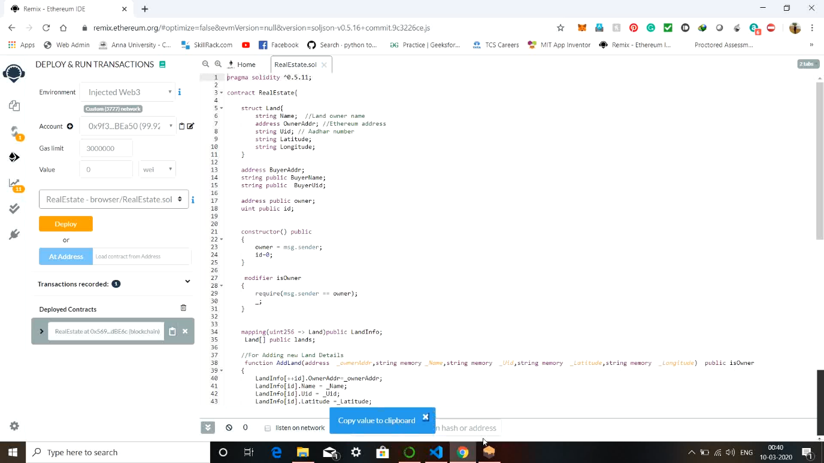

**Fig A1 Backend**

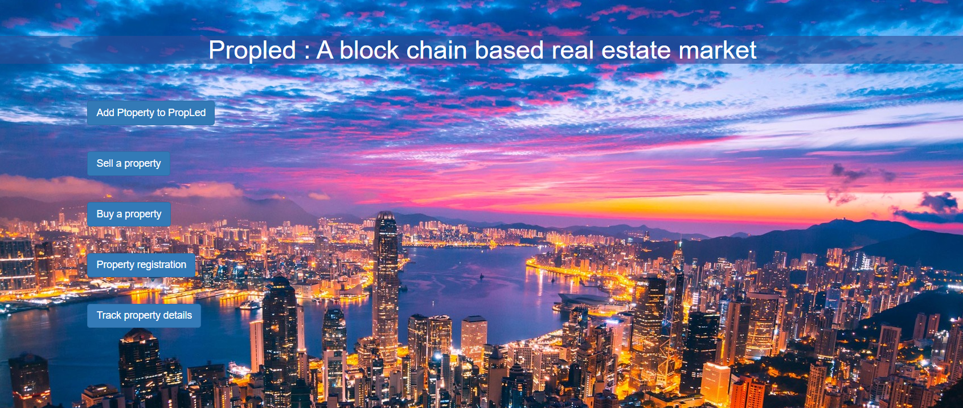

**Fig A2 Index page**

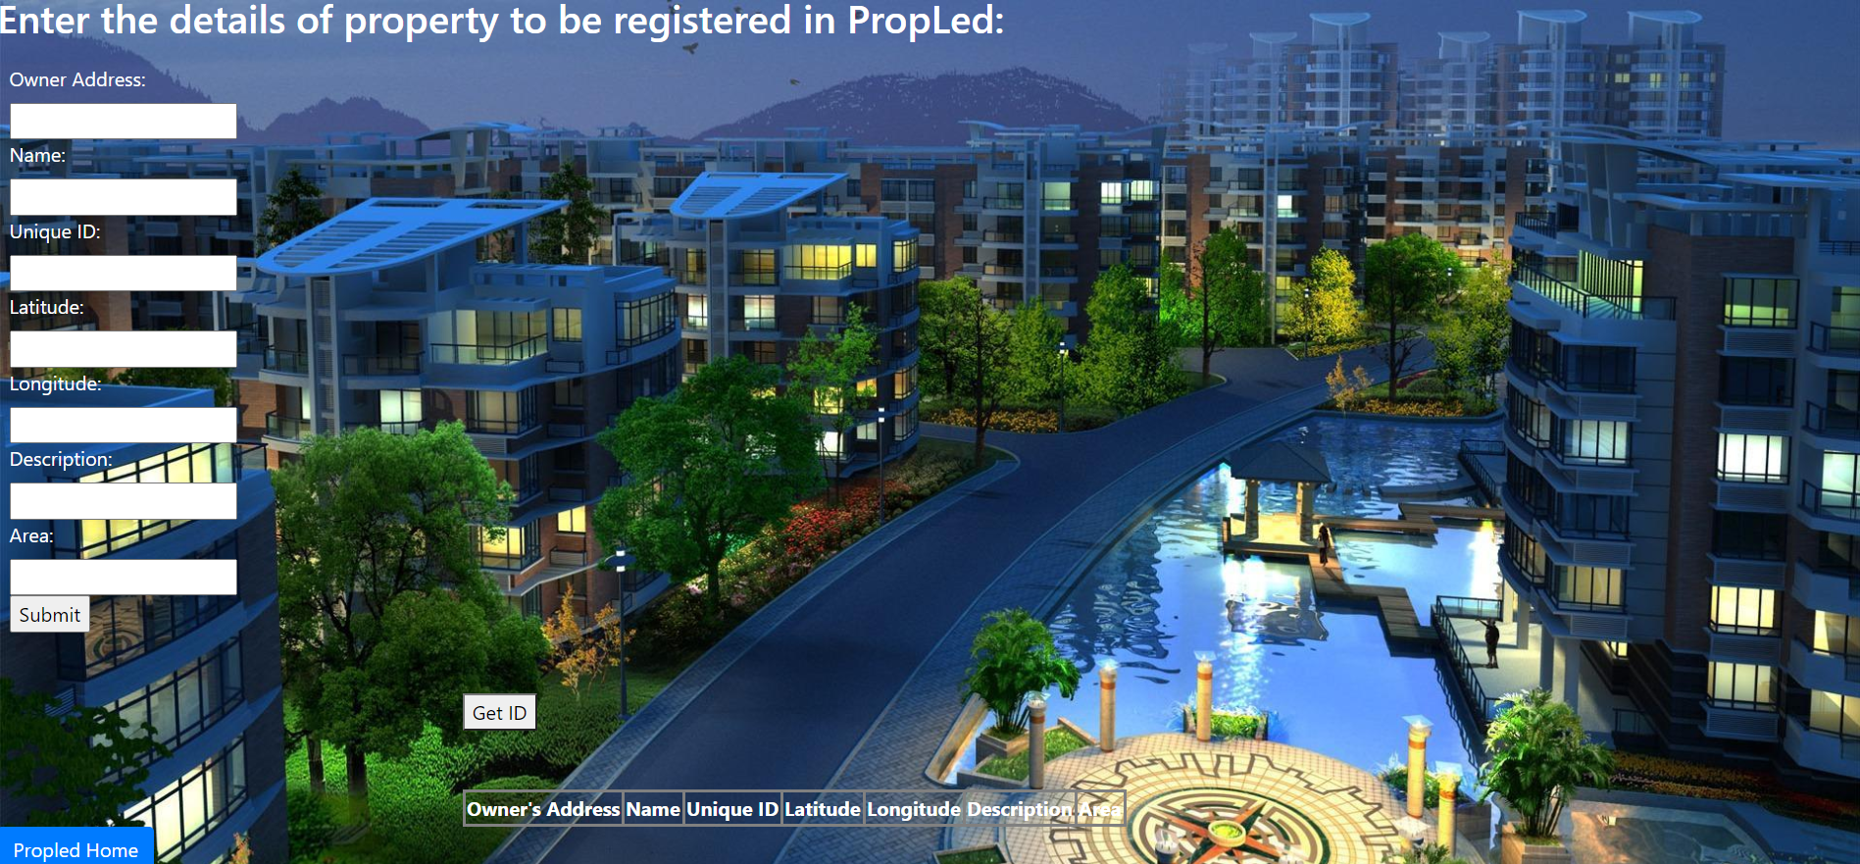

**Fig A3 Registering new land to system**

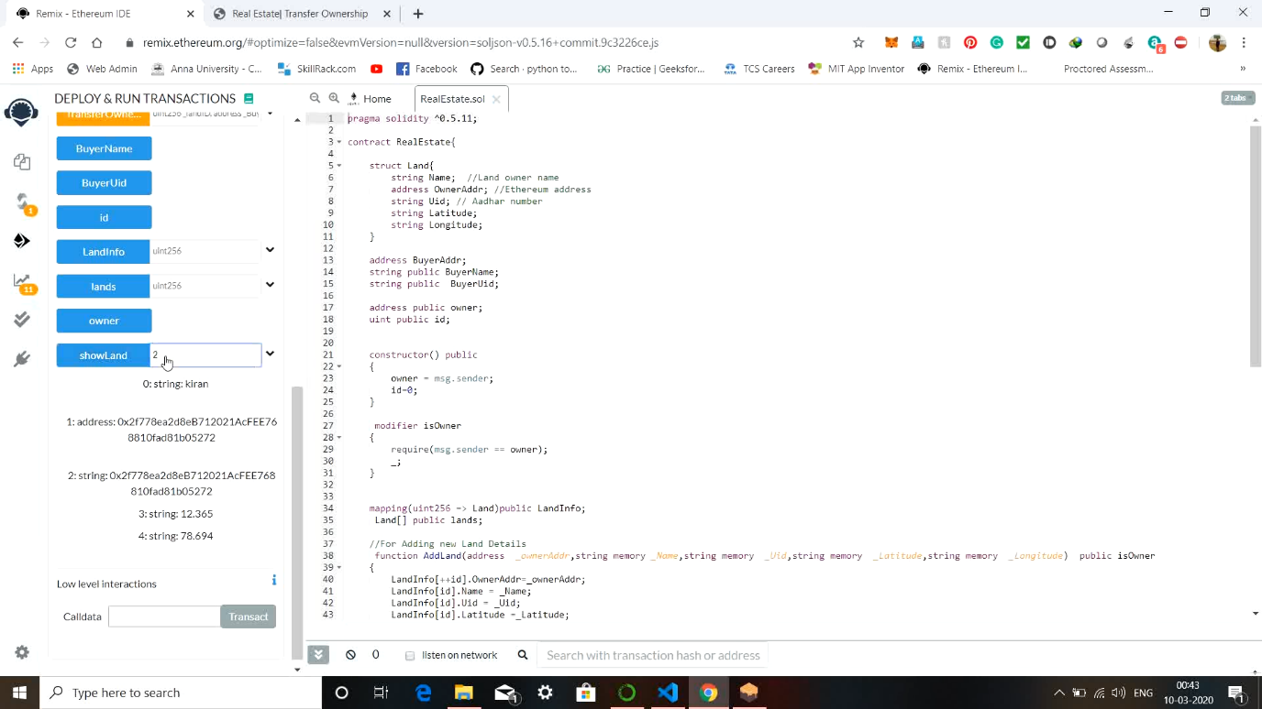

**Fig A4 Validation at back end**

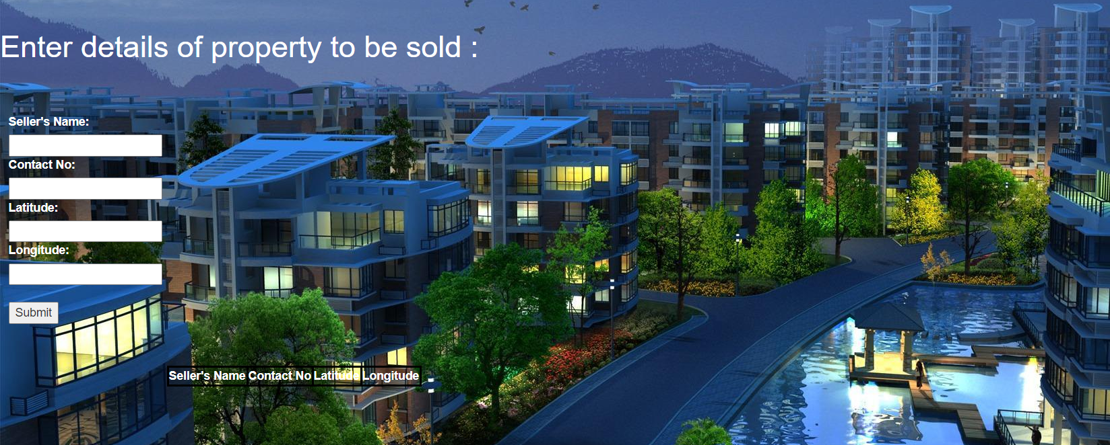

**Fig A5 Seller detail**

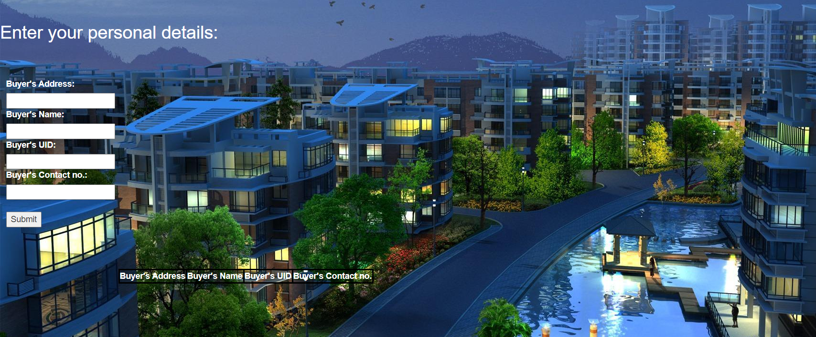

**Fig A6 Buyer detail**

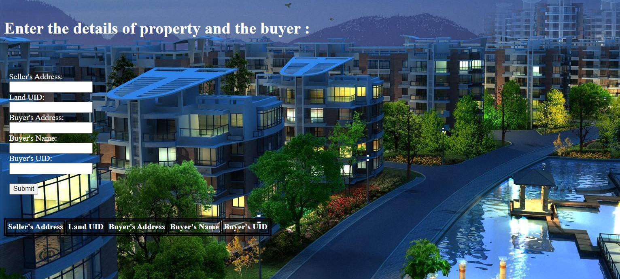

**Fig A7 Transferring ownership of land to buyer**

**CHAPTER 7**

**CONCLUSION AND FUTURE ENHANCEMENT**

This report presents a blockchain and smart contracts for real estate using Ethereum network. In this project, we used blockchain technology to provide security in the field of real estate market. By using smart contract which is deployed in the blockchain network which using latitude and longitude value binds with owner’s unique identification to ensure the avoidance of illegal activities. We used blockchain technology which is decentralized that helps to avoid intermediaries and reduction of brokerage. Our proposed system will speed up the transactions, reduce the cost and avoid tedious paper work, because our system is fully digitalized. By this innovative idea, we can provide more security to land details and for the real estate market with low cost and high speed.

The future enhancements may include a system which allows the system to be digitalised by emerging of cryptocurrencies the users can pay via various gateways which includes Bitcoin, Ether, etc. This will enhance the system leading more faster and fraud proof. This will allow a better serving of the community and will help user to build trust over the system.

**REFERENCES**

[1]. “Blockchain-based real estate market: one method for applying blockchain technology in commercial real estate market”-Sobhan Latifi, Yunpeng Zhang, Liang-Chieh Cheng.

[2]. “The impact of blockchain technology on the real estate sector using smart contracts” - Emadul Karim, Muhammad Mansab Uzair.

[3]. “Blockchain based E-voting recording system design.”- Rifa Hannifutsia, Budi Raharjo, in 11th International Conference on Telecommunication services and applications, TSA 2017.

[4]. “A critical review of Blockchain and its Current Applications.” -Bayu Adhi Tama, Bruno Joachim Kweka, Youngho Park, Kyung Hyunr Rhee.

[5]. “Smart contracts using block chain.”-Rajat Rawat, Rohan Chougle, Shivam Singh, Shivam Dixit, Anup Kadam, in International Research Journal of Engineering and Technology.

[6]. ” Council Post: Developments And Adoption Of Blockchain In

The U.S. Federal Government.” In Forbes, June, 2018.

[7]. The Impact of Blockchain Technology on the Real Estate Sector using Smart Contracts.

[8]. Secured Real Estate Transactions using Blockchain Technology.